Selcuk University Advanced Technology Research and Application Center (ILTEK) was established in 2009 on the Selcuk University Campus with the financing of the R&D project supported by the State Planning Organization, and with its modern devices and expert staff, it provides analysis for the studies carried out at universities, industry and public institutions/organizations and serves as a training center.
ILTEK Laboratories offers an internship programme for international students, providing them with the opportunity to enhance their research skills and gain experience across various disciplines. This programme not only imparts a global perspective but also enables students to learn analytical methods, utilize modern laboratory equipment, and engage in innovative projects. Recognizing the importance of internationalization, this internship programme offers significant advantages for students' academic and professional careers.
The international internship programme affords interns the chance to develop their technical skills and acquire a global vision to diverse cultural and scientific approaches. This experience fosters a deeper understanding of international cooperation and broadens their career perspectives. Through its international internship programme, ILTEK Laboratories cultivates an environment that benefits both the students and the host institution. Interns from different countries contribute to ILTEK's research and development activities by bringing innovative ideas and diverse viewpoints. This interaction enhances ILTEK's international reputation and strengthens the university's capability to undertake national and international projects.

Collaboration for Science

Beyond Borders:
Memories of International Internships
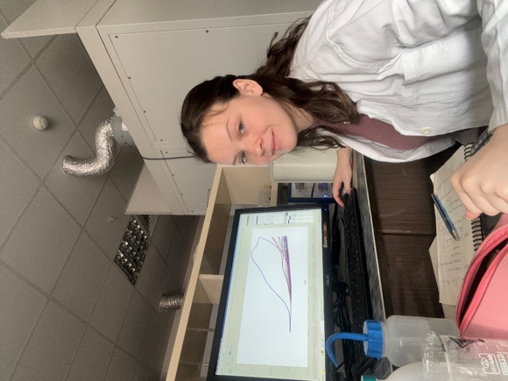 | Name & Surname | Adela Dobiasova
 | Country | Czech Republic
 | University | VSB – Technical University of Ostrava
 | Department | Chemical and Environmental Engineering
 | Dates of Internship | 20.11.2024 - 14.02.2025
I am grateful for the opportunity to work on my bachelor thesis as an intern at ILTEK research center and complete the experiments for my bachelor thesis. This experience showed me new possibilities in the chemistry, gave me new connections and friendships and unforgettable memories.
I would like to thank the whole team of the ILTEK as research centre and the Erasmus Office of Selcuk University for making this collaboration a reality. The biggest thanks go to Prof. Dr. Yasemin ÖZTEKİN for her patient approach in guiding my work and to the MSc student Neslihan ŞENTÜRK who was helpful in carrying out the experiments.

Beyond Borders:
Memories of International Internships

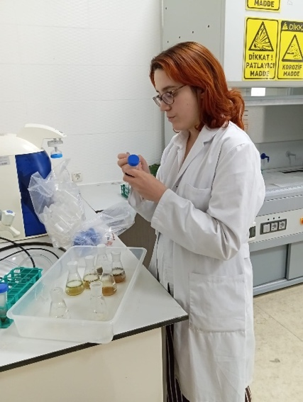 | Name & Surname | Maria Laguna
 | Country | Spain
 | University | UAH – University of Alcala
 | Department | Forensic Chemistry
 | Dates of Internship | 17.09.2025 - 03.12.2025

I am grateful for the opportunity to work as an intern at the Advanced Technology Research and Application Center (ILTEK) and perform a study about plant toxicology. This project has strengthened both my lab skills and my methodical thinking, working alongside experienced professionals and learning industry standards.
In addition to my professional growth, this experience gave me new connections and friendships and provided unforgettable memories that I will cherish forever. My stay in Turkey opened my mind to a more globally conscious perspective. These three months have significantly contributed to my education and future career in an enriching environment and culture.
I would like to express my sincere gratitude to ILTEK and Selçuk University for providing me with the facilities and resources necessary to carry out this work. I am especially thankful to Dr. Ayşegül KORKMAZ and ILTEK’s director Dr. Yasemin ÖZTEKİN, whose guidance and support throughout the process were crucial to the success of this study.

